**Reminder:** To receive credit for this assignment, do not forget to include the date/time in the screenshots requested for this lab and that your scripts are properly commented at the top and throughout it. This week, you will be using 2 walkthroughs to complete Week 4 Tool Development Exercise 2:

* SP25 Week 4 PowerShell PyCharm Walkthrough
* SP25 Week 4 Tool Development Exercise 2 Walkthrough

**Please include your GitHub Repository link at the bottom of this assignment.**

**NOTE:** Be sure that you change your script’s file extension to .txt so it will be accepted by BrightSpace.

**Submission Requirements:**

* Submit the following through Brightspace:
  + Script files
  + Assignment 4 document (**this document**) with all required screenshots.

**1. Blank PowerShell Script Screenshot**

(Use: *SP25 Week 4 PowerShell PyCharm Walkthrough*. This screenshot can be taken in any ISE/IDE of your choosing, it just needs to show a blank PowerShell script created/opened.)

**2. Python Scripting : Scenario 1 - User Privilege Level Check**

**Script Output Screenshot**

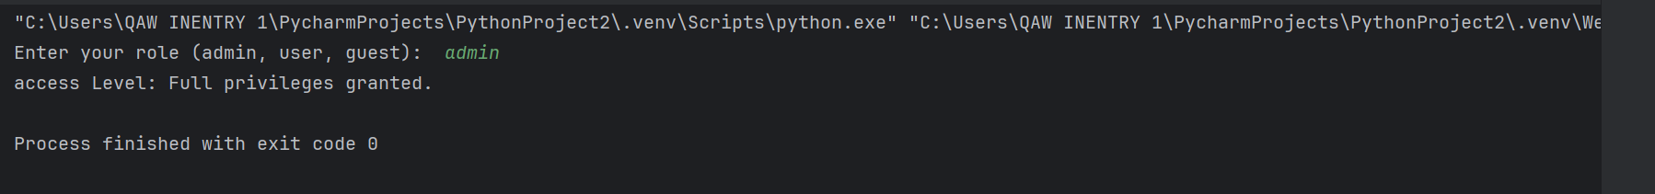

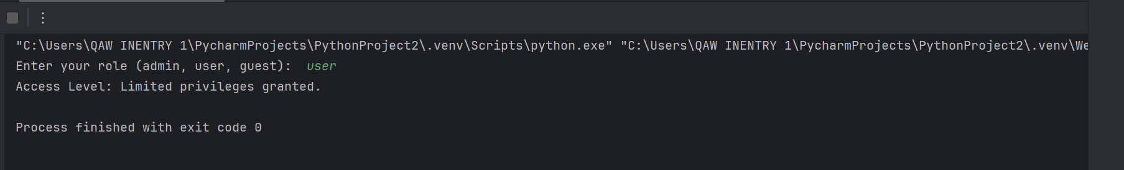

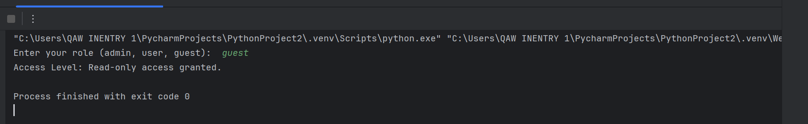

**3. Bash Scripting : Scenario 2 - System Health Check**

**Script Output Screenshot**

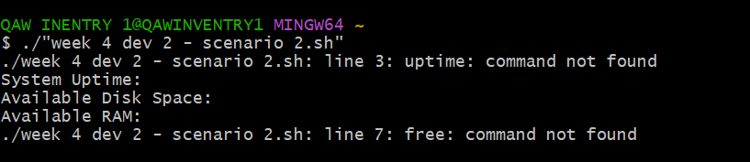

**4. PowerShell Scripting : Scenario 3 - Execution Policy Check**

**Script Output Screenshot**

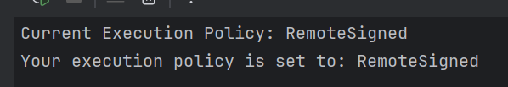

**5. PowerShell Scripting : Scenario 4- User Account Type Checker**

**Script Output Screenshot**

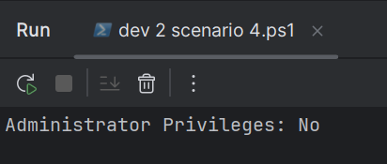

**6. PowerShell Scripting : Scenario 5 - Environment Variable Inspector**

**Script Output Screenshot**

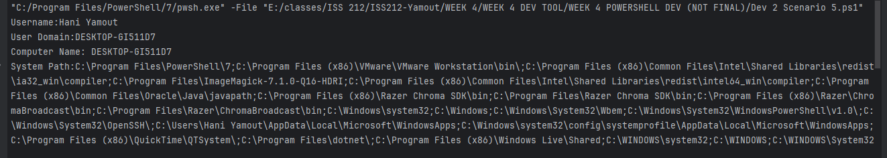

***Note: Scenario 5 is running on a different machine than the other scenarios on here***

**7. PowerShell Scripting : Scenario 6 - Port Scanner Simulation**

**Script Output Screenshot**

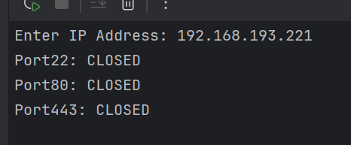

**8. GitHub Repository Link: https://github.com/hyamout/ISS212-Yamout**